# Lab 12: Hiding and Showing Components

## Objectives

*  Add state to a component
*  Hide and show a component

## Steps

### Add state to a component

1. Add a state variable projectBeingEdited to hold which project is currently being edited. And update handleEdit to set the projectBeingEdited variable.

#### src\projects\ProjectList.js

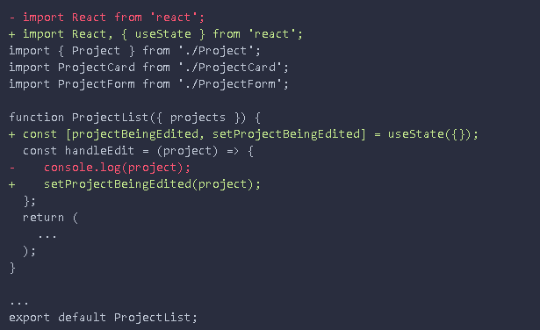

### Hide and show a component

1. Conditionally render the ProjectForm when the projectBeingEdited equals the current project in the list, otherwise display a ProjectCard .

#### src\projects\ProjectList.js

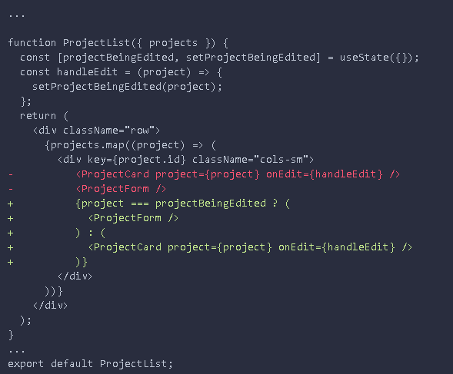

1. **Verify** the application is **working** by following these steps:
2. **Open** the application in your browser and refresh the page.
3. **Click** the **edit** button for a project.
4. **Verify** the <ProjectCard /> is removed and replaced by the <ProjectForm/>.

The <ProjectForm/> will be empty at this point. We will fill in the data in a future lab.

You can do click another edit button on another ProjectCard and that card will change to a form. At this point, you may notice that the cancel button doesn't work. We will get that working in the next lab.

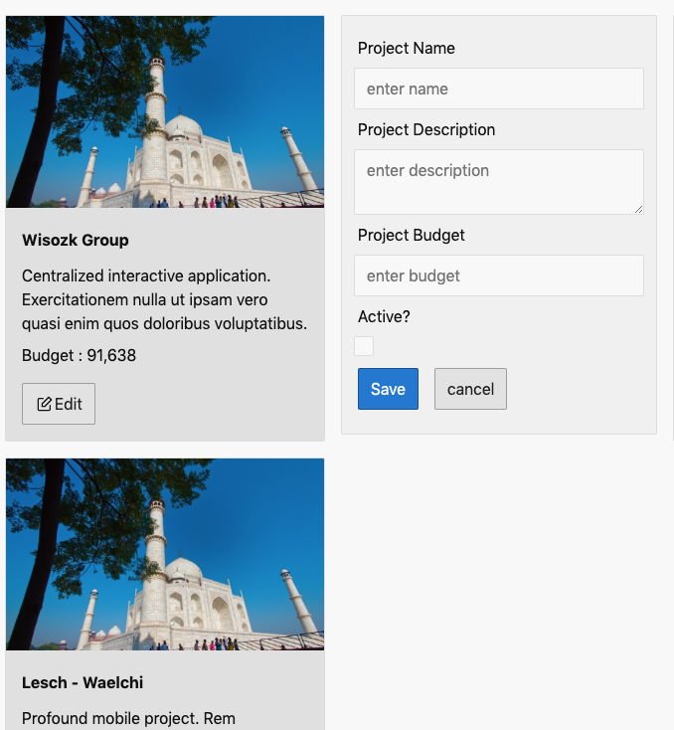

### ✔ You have completed Lab 12